# LAPORAN ANALISIS UTS DATA SCIENCE



Oleh:

# Ricko Caesar Aprilla Tiaka

NIM: 2011102441099

**PROGRAM STUDI TEKNIK INFORMATIKA FAKULTAS SAINS DAN TEKNOLOGI**

**UNIVERSITAS MUHAMMADIYAH KALIMANTAN TIMUR SAMARINDA**

**2023**

LEMBAR JAWABAN SOAL

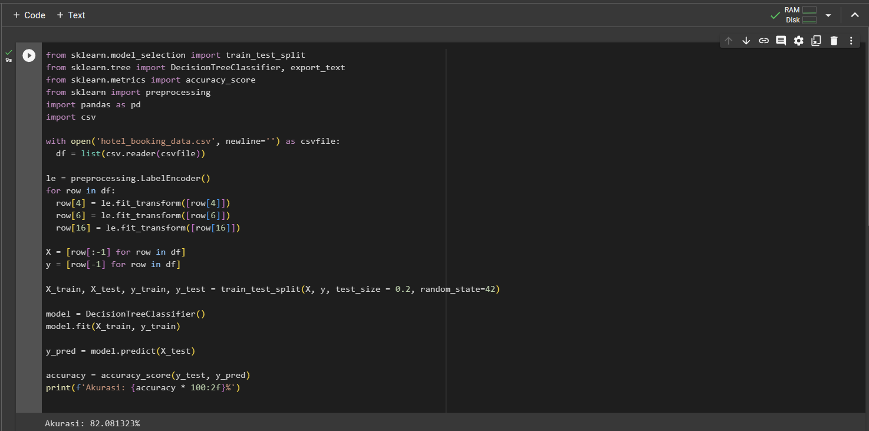

Link Google Drive : [https://drive.google.com/drive/folders/13jB75C_h2xX5-mmZXAb-KfMLqicRjvHk?usp=sharing](https://drive.google.com/drive/folders/13jB75C_h2xX5-mmZXAb-KfMLqicRjvHk?usp=sharing%20)